Exercise:

**Q.1) What is meant by the term cryptography?**

**Answer:** Cryptography is associated with the process of converting ordinary plain text into unintelligible text and vice-versa. It is a method of storing and transmitting data in a particular form so that only those for whom it is intended can read and process it.

**Q.2) Why network security is needed?**

**Answer:** Most homes with high-speed internet connections have one or more wireless routers, which could be exploited if not properly secured. A solid **network security** system helps reduce the risk of data loss, theft and sabotage.

**Q.3) What is the difference between running-config & startup-config?**

**Answer:** A **running configuration** resides **in a** device's RAM, so if a device loses power, all configured commands will be lost.

A **startup configuration** is stored **in the** nonvolatile memory of a device, which means that all configuration changes are saved even if the device loses power

**Q.4) what is meant by the term backup and why its necessary?**

**Answer:** The purpose of the **backup** is to create a copy of data that can be recovered in the event of a primary data failure. Primary data failures can be the result of hardware or software failure, data corruption, or a human-caused event, such as a malicious attack (virus or malware), or accidental deletion of data

**Q.5) What is the difference between Service password encryption and enable secret command?**

**Answer: Service password**-**encryption** is used to **encrypt** all **passwords** on the device. The **difference** is that **enable secret** only encrypts a certain **password**, **service password**-**encryption** encrypts them all.

**Q.6) What is the purpose of show running configuration command?**

**Answer:**The **show running**-**config command shows** the router, switch, or firewall's current **configuration**. The **running**-**configuration** is the **config** that is in the router's memory. You change this **config** when you make changes to the router

**Topology:**

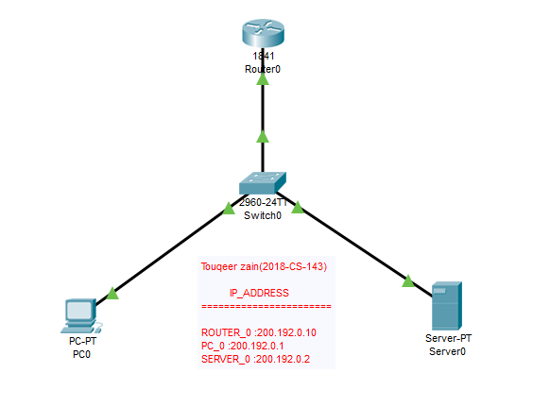

**Configure the password for User mode & privileged mode:**

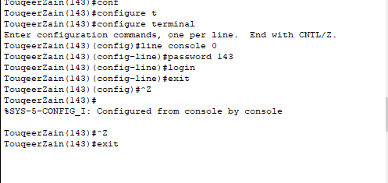

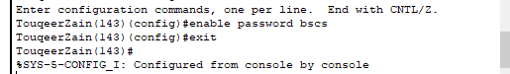

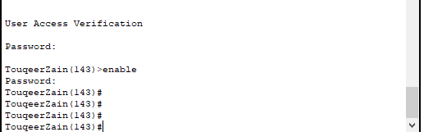

**Maintain backup on Router:**

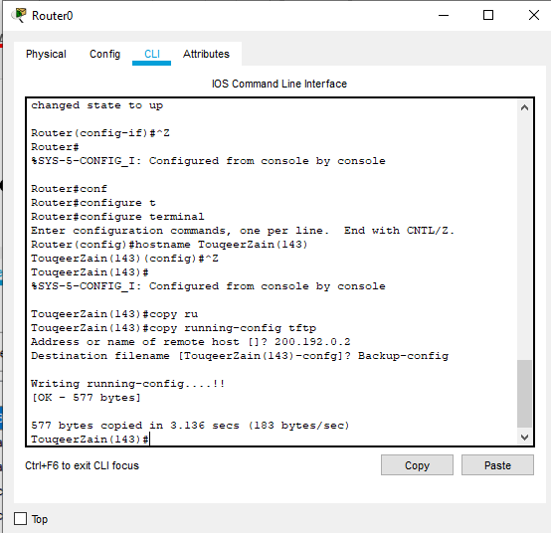

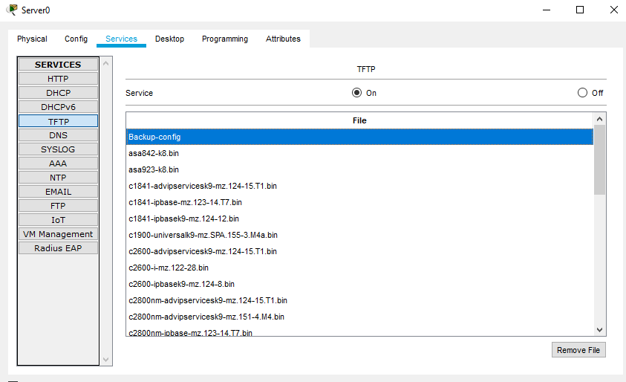

**RESTORE DATA ROM ROUTER:**

